LAB ASSIGNMENT-17.4
Task 1 – Employee Data Preprocessing
Task:
Use AI to generate a Python script for cleaning an employee dataset.
Instructions:
- Handle missing values in columns (salary, department, joining_date).
- Convert the "joining_date" column into proper datetime format.
- Standardize department names (e.g., "HR", "hr", "Human Resources" → "HR").
- Encode categorical variables (department, job_role).
Expected Output:
- A cleaned Pandas DataFrame with consistent departments, proper dates, and encoded features.

DATASET:

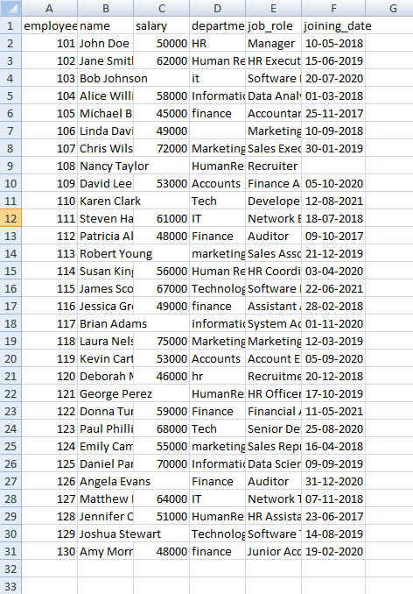
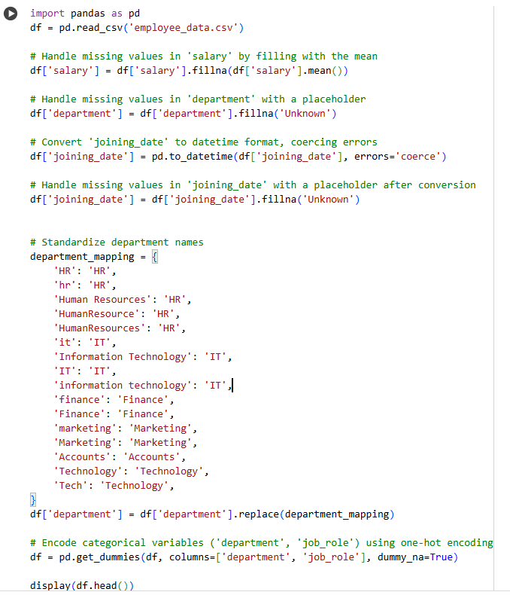

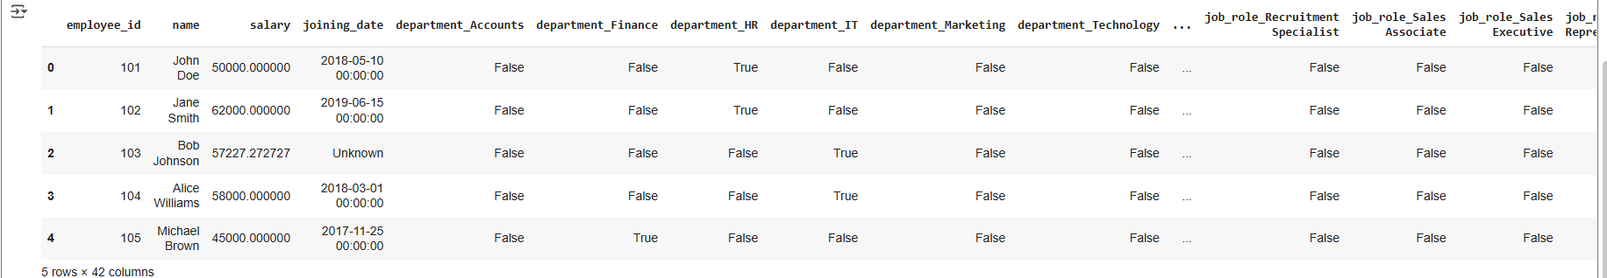

Task 2 – Sales Transaction Data Preprocessing
Task:
Use AI to generate a script for preprocessing a sales transaction dataset.
Instructions:
- Convert transaction dates to proper datetime format.
- Create a new column for “Month-Year” from the transaction date.
- Remove rows with negative or zero transaction amounts.
- Normalize the "transaction_amount" column using Min-Max scaling.
Expected Output:
- A preprocessedDataFrame with valid dates, normalized amounts, and no invalid records.

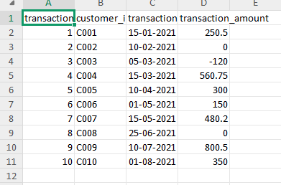

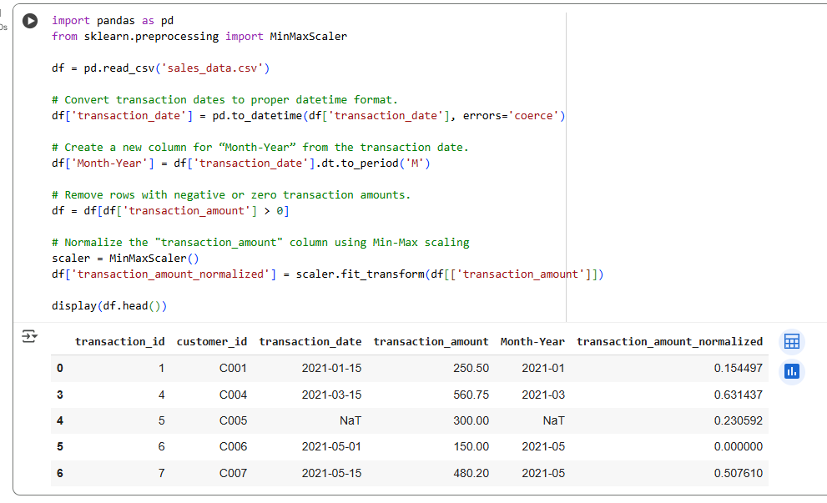

- import pandas as pd: Imports the pandas library for data manipulation and analysis.
- from sklearn.preprocessing import MinMaxScaler: Imports the MinMaxScaler from scikit-learn for feature scaling.
- df = pd.read_csv('sales_data.csv'): Reads the data from the 'sales_data.csv' file into a pandas DataFrame named df.
- df['transaction_date'] = pd.to_datetime(df['transaction_date'], errors='coerce'): Converts the 'transaction_date' column to datetime objects. If any value cannot be converted, it will be replaced with NaT (Not a Time).
- df['Month-Year'] = df['transaction_date'].dt.to_period('M'): Creates a new column 'Month-Year' by extracting the month and year from the 'transaction_date' column. The .dt.to_period('M') part formats it as a monthly period.
- df = df[df['transaction_amount'] > 0]: Filters the DataFrame to keep only rows where the 'transaction_amount' is greater than 0, removing negative or zero transaction amounts.
- scaler = MinMaxScaler(): Initializes a MinMaxScaler object, which is used to scale features to a given range (default is 0 to 1).
- df['transaction_amount_normalized'] = scaler.fit_transform(df[['transaction_amount']]): Normalizes the 'transaction_amount' column using the Min-Max scaler. It scales the values so they fall within a specific range (typically 0 to 1), which is often useful for machine learning algorithms.
- display(df.head()): Displays the first few rows of the processed DataFrame, including the new 'Month-Year' and 'transaction_amount_normalized' columns.

Task 3 – Healthcare Patient Records Cleaning
Task:
Use AI to generate a script for cleaning healthcare patient records.
Instructions:
- Fill missing values in numeric columns (e.g., blood_pressure, heart_rate) with column mean.
- Standardize units (convert height from cm to meters).
- Correct inconsistent categorical labels (e.g., "M", "Male", "male" → "Male").
- Drop irrelevant columns such as patient_id after cleaning.
Expected Output:
- A cleaned healthcare dataset suitable for ML model training.
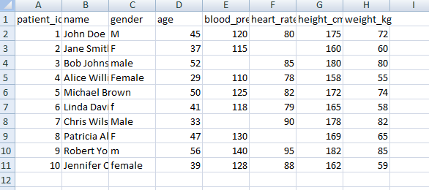
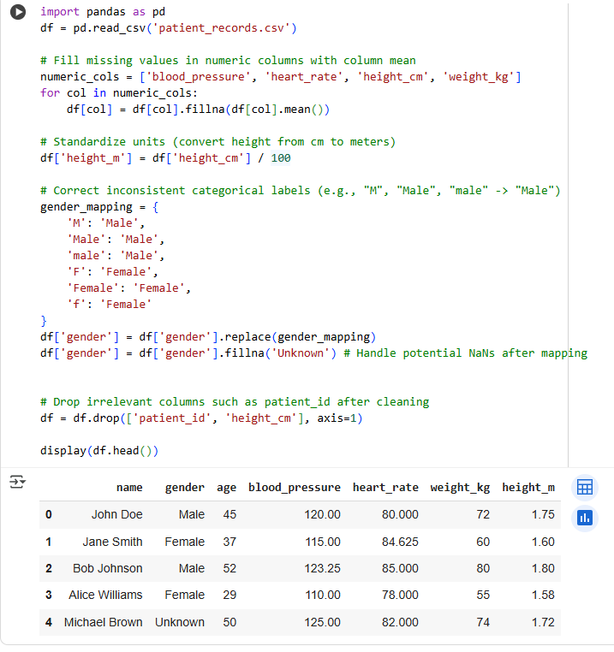
Task 4 – Social Media Sentiment Dataset Preparation
Task:
Use AI to write a script to preprocess a social media text dataset.
Instructions:
- Remove special characters, URLs, and emojis from text.
- Convert all text to lowercase.
- Tokenize and remove stopwords.
- Apply lemmatization for standardizing words.
Expected Output:
- A processed dataset with clean text, ready for NLP sentiment analysis.
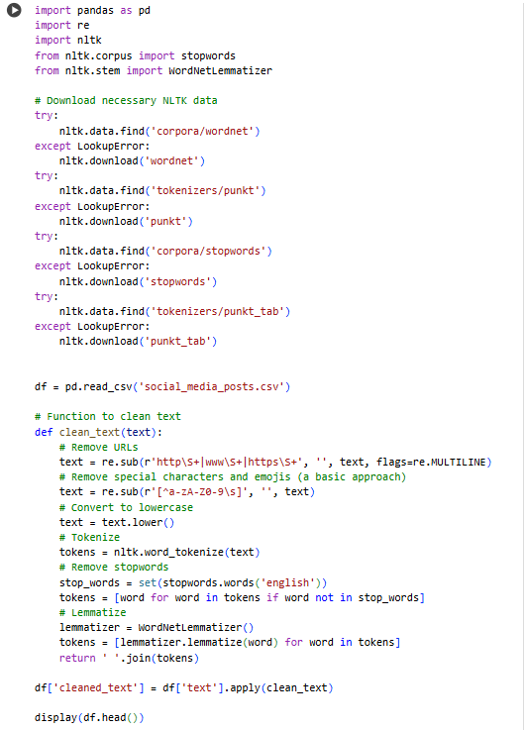

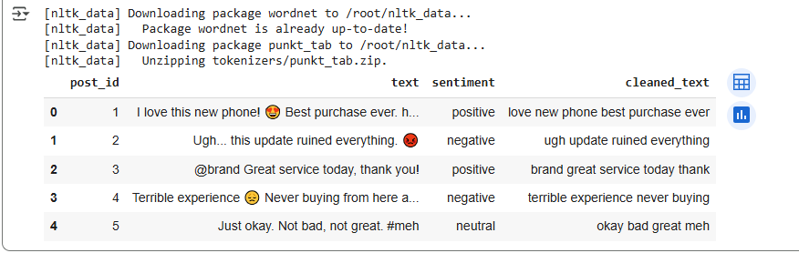

Task 5 – Financial Dataset Feature Engineering
Task:
Use AI to create a preprocessing script for a financial dataset.
Instructions:
- Handle missing values in stock price and volume.
- Create new features such as moving average (7-day, 30-day).
- Normalize continuous variables using StandardScaler.
- Encode categorical columns (sector, company_name).
Expected Output:
- A feature-engineered DataFrame with new indicators and normalized values for ML tasks.
